**ASTROSAGE CALL CENTER DATA ANALYSIS**

**ANSWERS OF OBJECTIVE QUESTIONS**

**Q1**: What is the total no. of tables present in the data?

**Ans**: **1** Table (in the sheet **DATA**).

**Q2**: What is the total no. of attributes present in the data?

**Ans**: 35 Attributes (Columns in the sheet named **DATA**).

28 Attributes (Columns in the sheet named **Cleaned Data**).

**Q3**: The data consists of some inconsistent and missing values so ensure that the data used for further analysis is cleaned.

**Ans**:During the initial data audit, missing values were identified in several columns. Before addressing these gaps through imputation, a duplicate check was performed to ensure data integrity, and no duplicate records were detected.

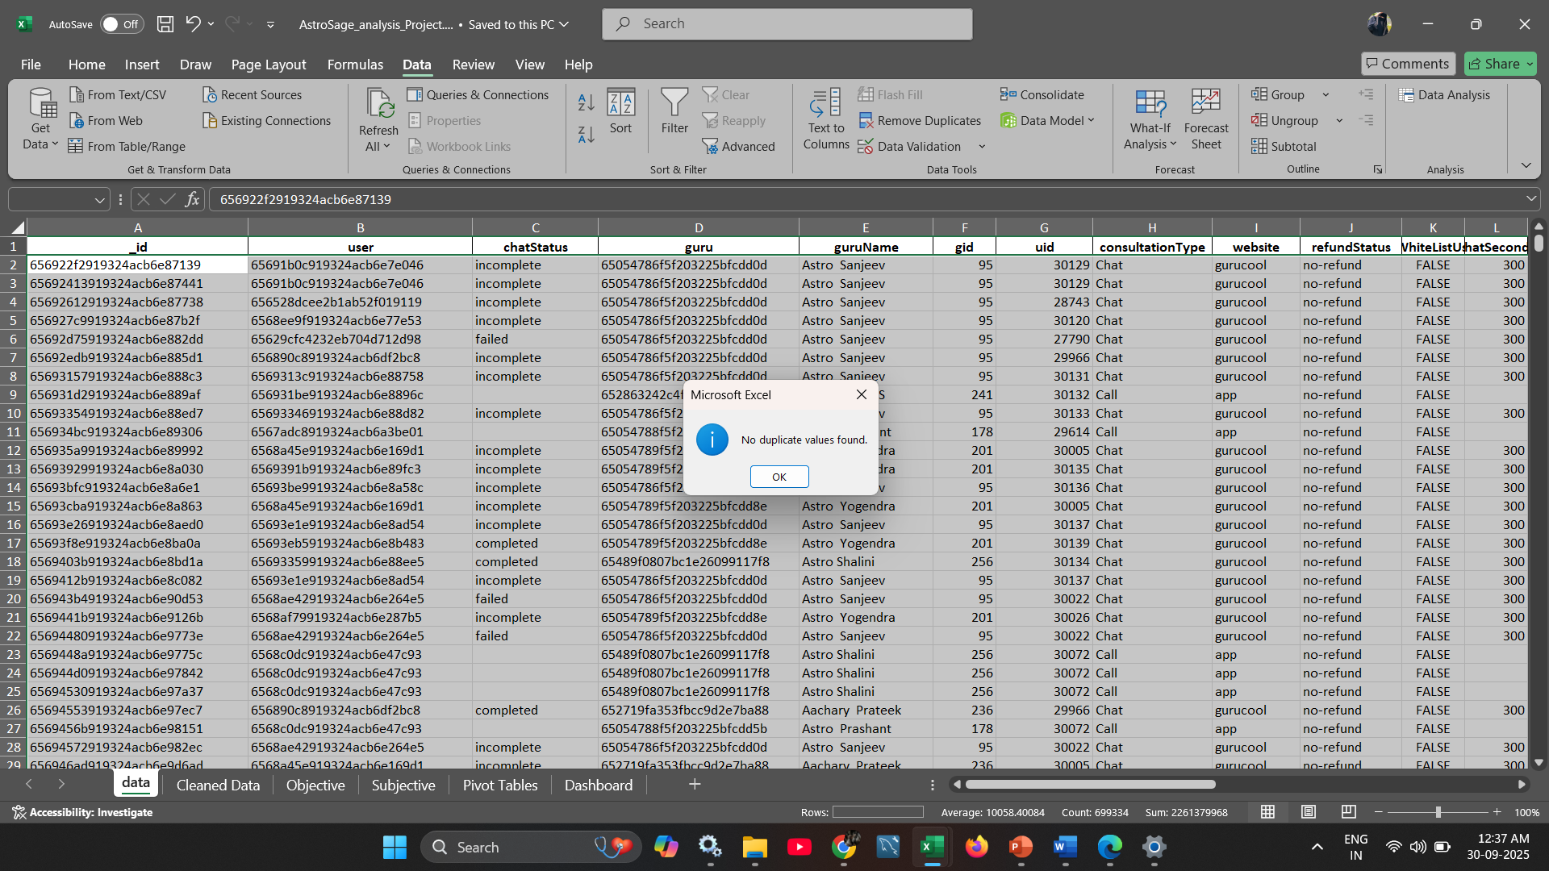

**Duplicate Removal Process:**

* Navigated to: **Data → Data Cleanup → Remove Duplicates**
* Outcome: No duplicate entries detected.

**Imputation and Data Transformation Steps:**

* **chatStatus**: Contained empty cells. Since all blank entries corresponded to call-based interactions, I imputed missing values with "**call**".
* **Date-Time Extraction** from the createdAt column:
  + **Date**: =TEXT(P2,"YYYY-MM-DD")
  + **Month**: =TEXT(P2,"MMM")
  + **Year**: =TEXT(P2,"YYYY")
  + **Time**: =TEXT(P2,"HH:MM:SS")
  + **Hour**: =TEXT(P2,"H")
* **Missing Categorical Fields**:
  + For **callChannel** and **callIvrType**, missing values were replaced with "**N/A**" using:
    - =IF(ISBLANK(Value),"N/A",Value)
* **Missing Numerical Fields**:
  + Columns like amount, **astrologerOnCallDuration**, **astrologersEarnings**, **netAmount**, and **userOnCallDuration** were imputed with **0**:
    - =IF(ISBLANK(Value),0,Value)
* Created two new columns **ConsultationDuration** and **ConsultationStatus** by using **IF** and **ISBLANK** function.

**Column Exclusion:**

To streamline the dataset and improve performance, irrelevant or unused columns were removed, including:  
 **user, guru, refundStatus, isWhiteListUser, queue, freeCall, freeChat, updatedAt, _v, statementEntryId, chatStartTime, chatEndTime, timeDuration** and others**.**

**Q4**: What is the change in daily call volume day by day and also find the average daily call volume.

**ANS:** To analyze the average daily call volume, the following steps were undertaken:

1. A **Pivot Table** was created with:
   * **Date** placed in the **Rows** section.
   * **callSid** placed in the **Values** section **(set to Count)** to determine the number of calls per day.
2. To calculate the **daily change in call volume**, I used the formula: **=E7-E6** —applied sequentially to observe fluctuations from one day to the next.
3. To derive the **average daily call volume**, the following formula was applied across the daily call counts:  **=AVERAGE (C6:C39)**

The resulting average daily call volume was **246.029** calls.

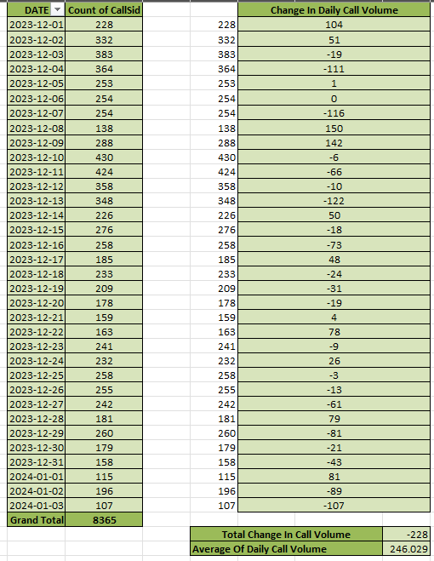

**Q5**: Which months experienced the highest and lowest call volumes?

**ANS:** To identify the **months with the highest and lowest call volumes**, I created a **Pivot Table** by:

1. Placing **Month** in the **Rows** section.
2. Adding **callSid** in the **Values** section (set to **Count**) to calculate the total number of calls per month.
3. Add **consultationType** in the filter and select **call.**

This setup provided a clear view of monthly call volumes, enabling easy comparison and identification of peak and low-performing months.   
  
 Highest - **December** Lowest – **January**

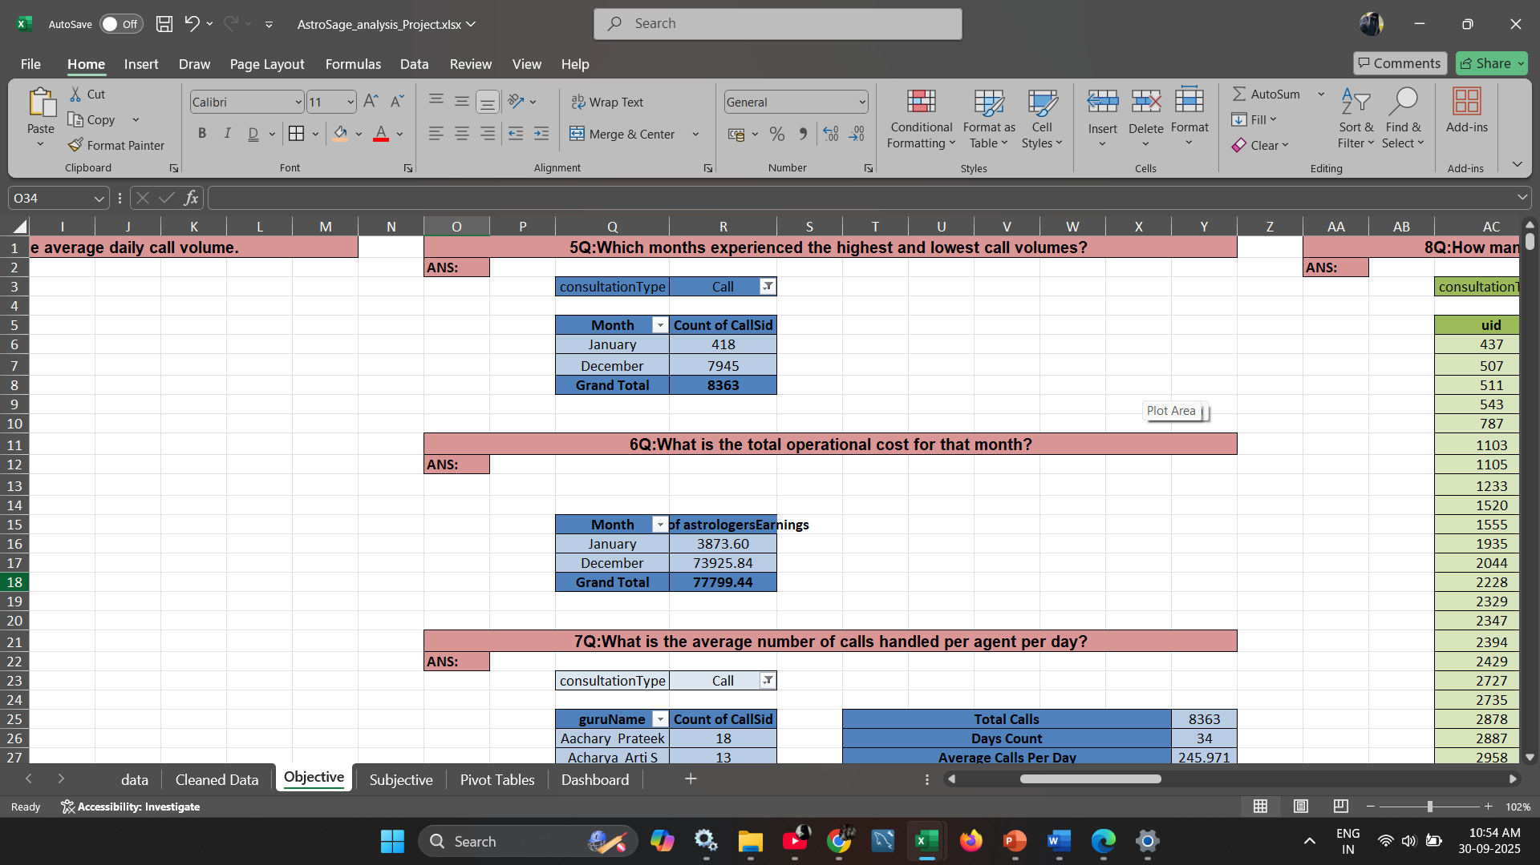

**Q6**: What is the total operational cost for that month?

**ANS:**  To analyze the **operational cost for each month**, I created a **Pivot Table** with the following structure:

1. Placed **Month** in the **Rows** section.
2. Added **Astrologers’ Earnings** in the **Values** section (set to **Sum**) to calculate the total operational cost incurred per month.

This helped in identifying the financial outflow towards astrologers for each month and assessing cost patterns.  
 January - **5360.41** December - **93786.16**

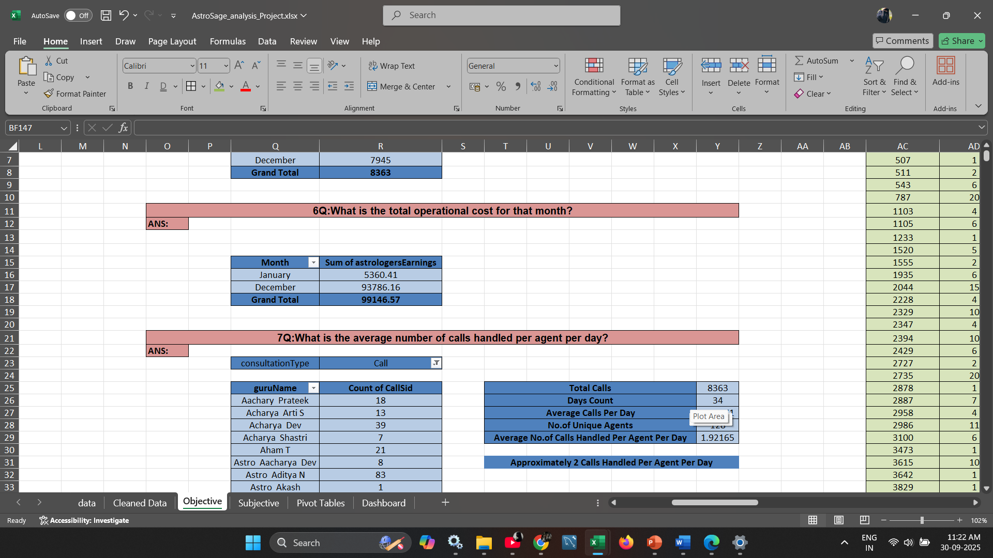

**Q7**: What is the average number of calls handled per agent per day?

**ANS:** To analyze the **average number of calls handled per agent per day**, I created a **Pivot Table** with the following structure:

1. Placing **guruName** in the **Rows** section.
2. Adding **callSid** in the **Values** section (set to **Count**) to calculate the total number of calls per month.
3. Add **consultationType** in the filter and select **call.**

To calculate the **average number of calls handled per agent per day**, I followed these steps:

* Calculated the **total number of calls** using the **COUNT** function on the call ID column.
* Determine the **number of unique agents** using the **UNIQUE** function on the guruName column.
* Found the **total number of operational days** using the **COUNT** function on the date column.
* Then, I applied the following formula to derive the final result:  
  **= (Total Calls / Number of Agents) / Number of Days**

Average calls handled per agent per day - **2 calls (approximate of 1.92165)**

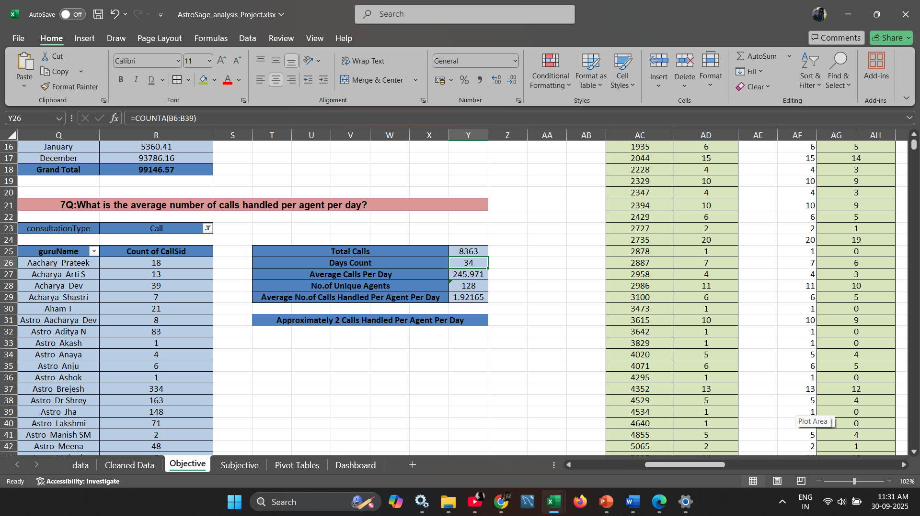

**Q8**: How many repeat callers are there, and what percentage of total calls do they represent?

**ANS:** Analysis of Repeat Callers:

Based on the collected data, the total number of unique callers recorded was 10,344, out of which 1,275 were identified as repeat callers — meaning these individuals contacted the call center more than once during the analysis period.

Sum of Repeat callers - **4734**  
Percentage: (4737/8363)*100=**56.6%**

In total, the call center handled 8,363 calls, and 4,737 of these calls were made by repeat callers. This accounts for approximately 56.64% of the total call volume.

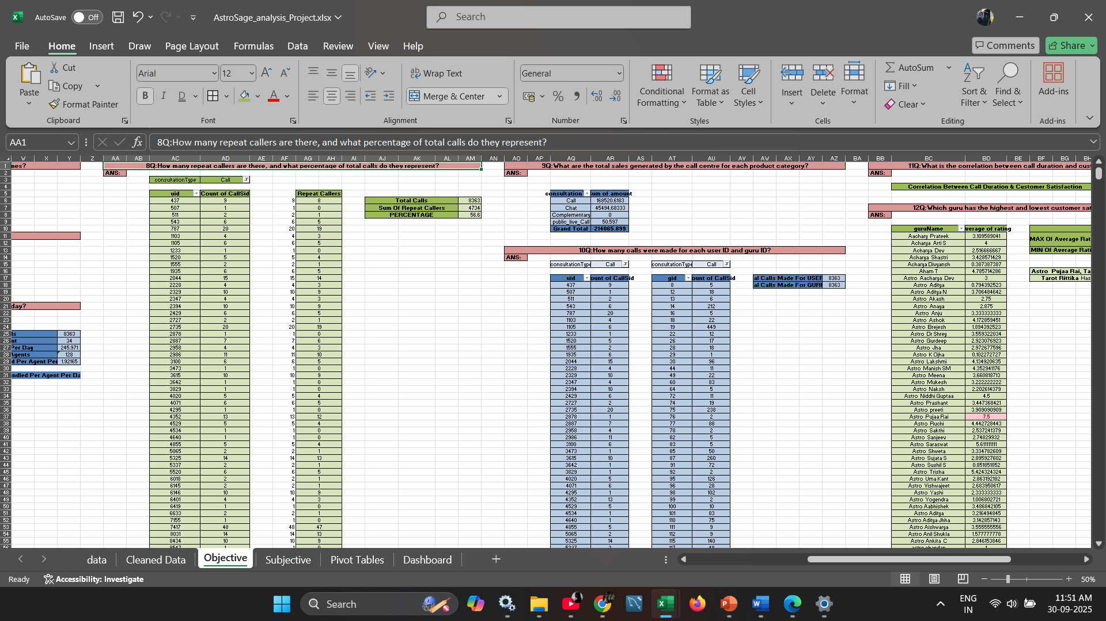

**Q9**: What are the total sales generated by the call centre for each product category?

**ANS:** To calculate the **total sales generated by each product category**,

I created a **Pivot Table** with **Consultation Type** in the **Rows** section and the **Sum of Amount** in the **Values** section. This helped in effectively aggregating the sales figures across each consultation type. The breakdown of the total sales is as follows:

* **Call**: 168520.6183
* **Chat**: 45494.68333
* **Complementary**: 0
* **Public Live Call**: 50.597

This analysis provided a clear view of revenue contribution by each product line.

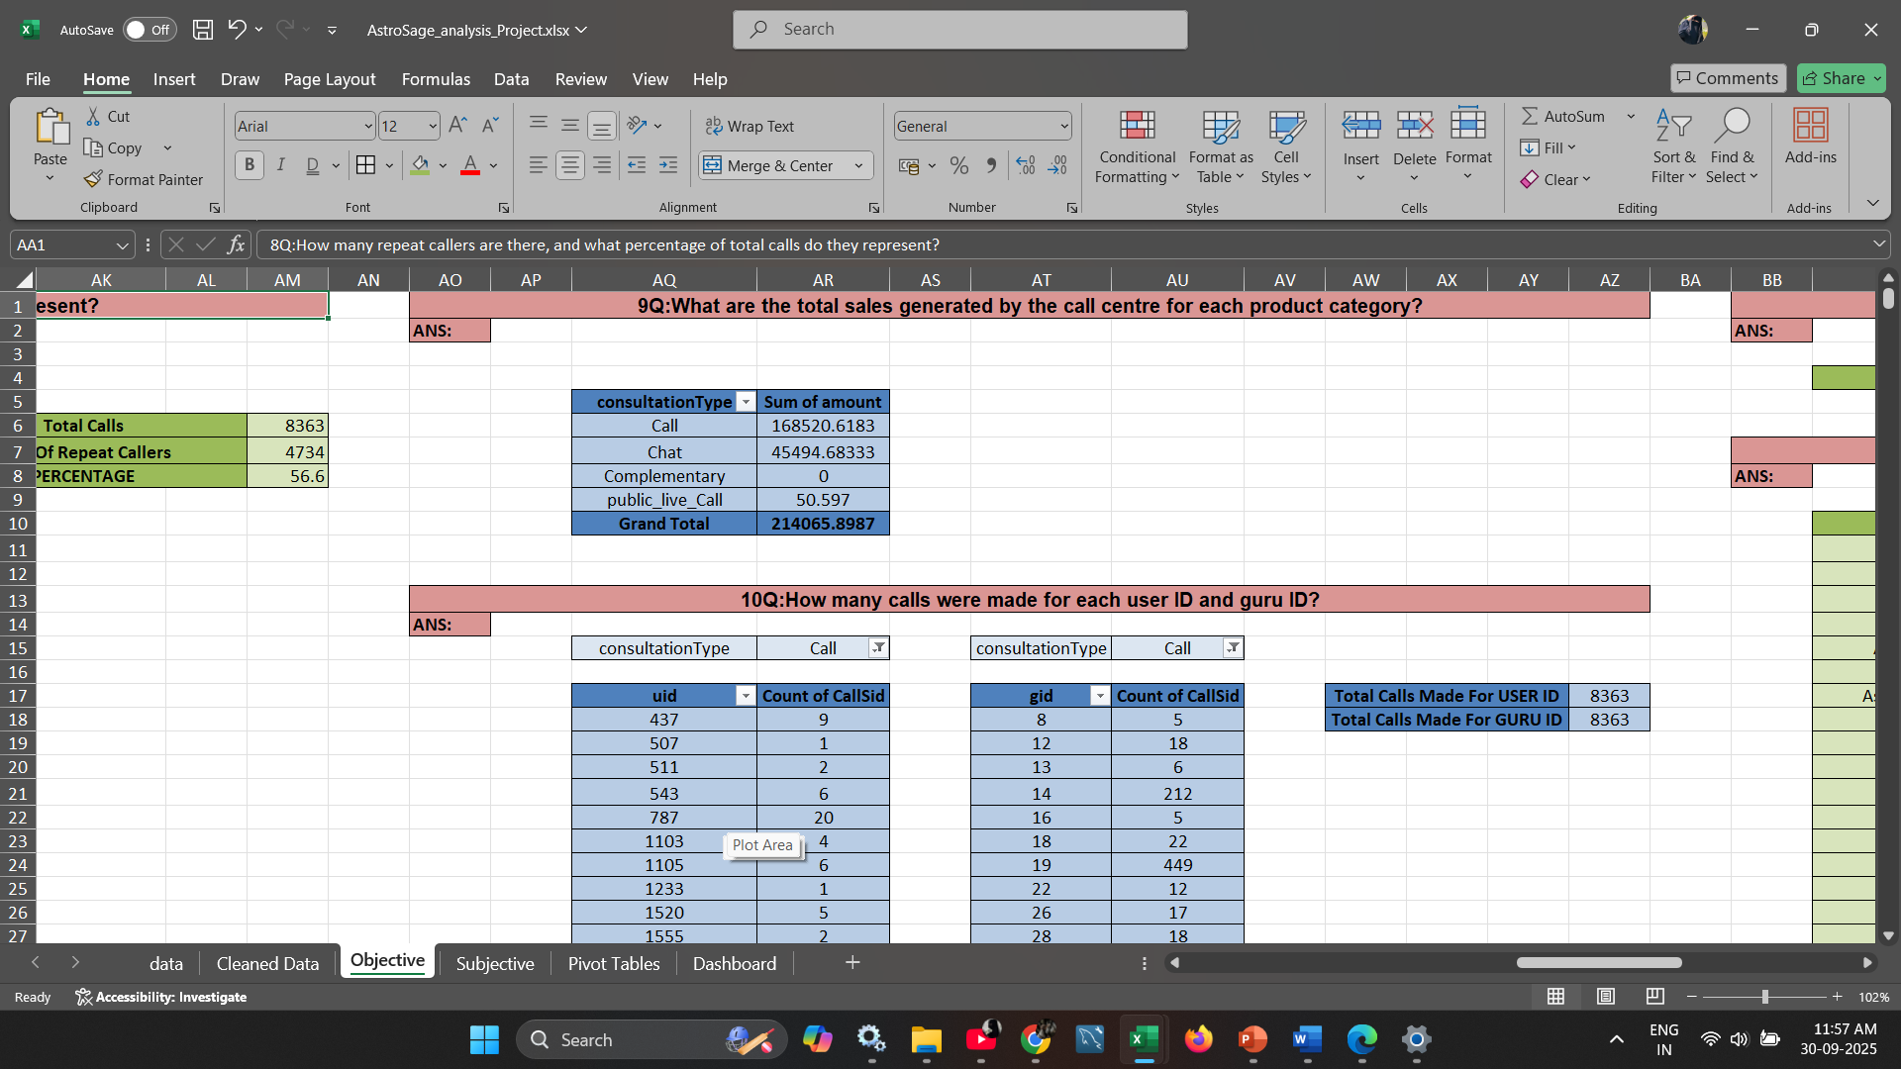

**Q10**: How many calls were made for each user ID and guru ID?

**ANS: To calculate the number of calls made based on Uid and Gid:**

* Created a **Pivot Table** using the Cleaned data.
* Dragged **Gid** and **Uid** into the **Rows** section to group data by astrologer and user.
* Added **CallSid** to the **Values** section and set it to **Count**, to get the number of calls.
* Applied a **filter** to include only entries where the interaction type was **"call"**.

This setup allowed me to identify the **total number of calls** made by each user and each astrologer.

Total Calls were made of User Id - **8363**Total Calls were made of Guru Id – **8363**

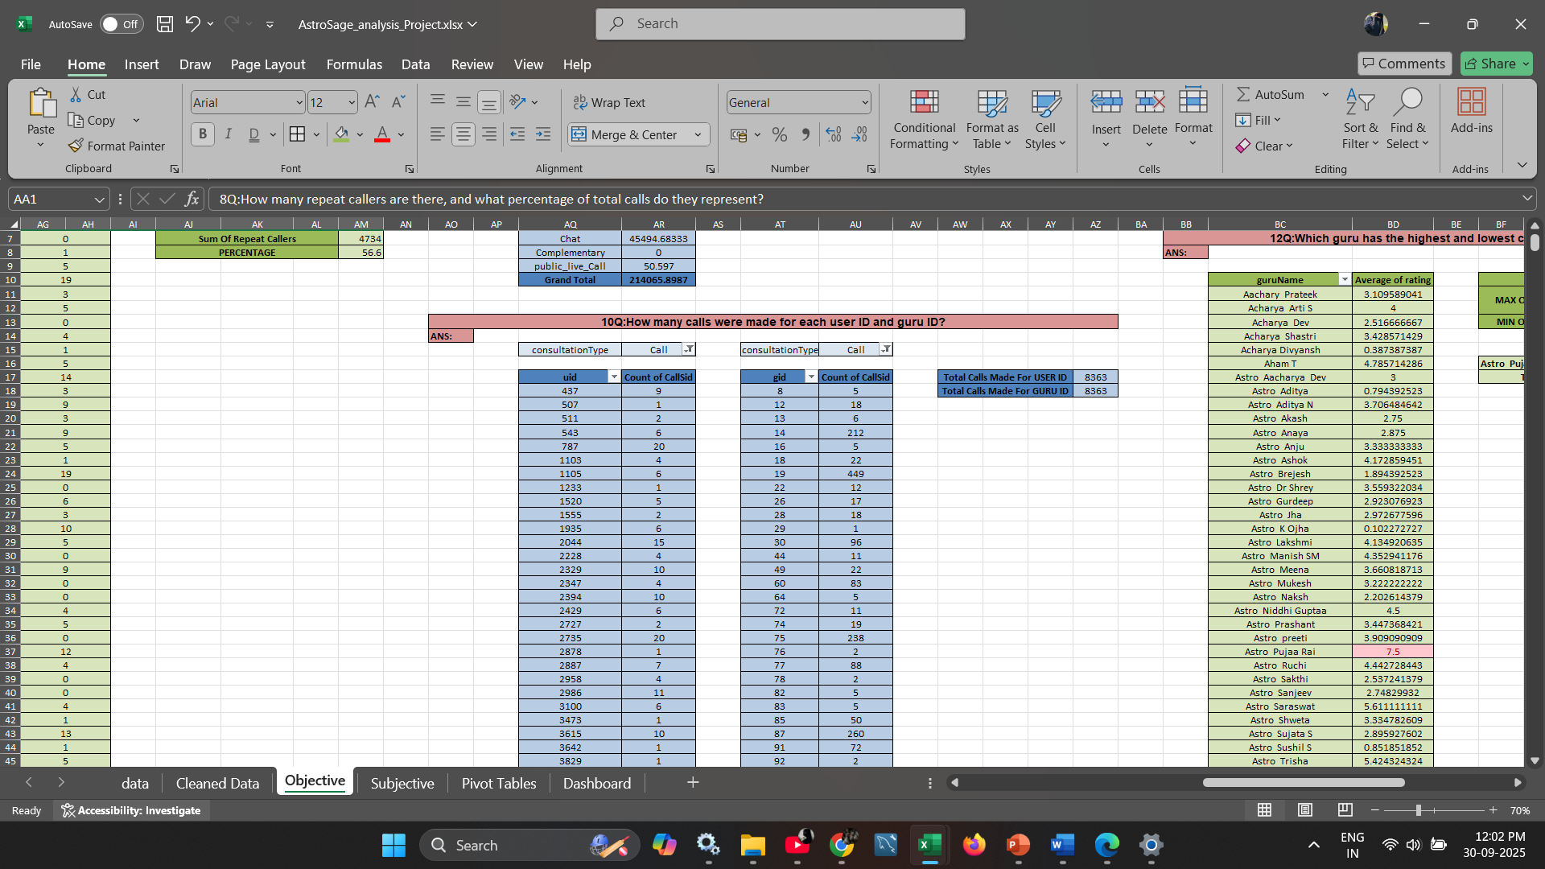

**Q11**: What is the correlation between call duration and customer satisfaction?

**ANS: To determine the correlation between call duration and customer satisfaction:**

* I used the **CORREL** function in Excel to assess the relationship.
* Selected the **userOnCallDuration** and **rating** columns from the cleaned dataset as input.
* The resulting correlation coefficient was **0.05476**, indicating a **very weak positive relationship** between call duration and customer satisfaction.

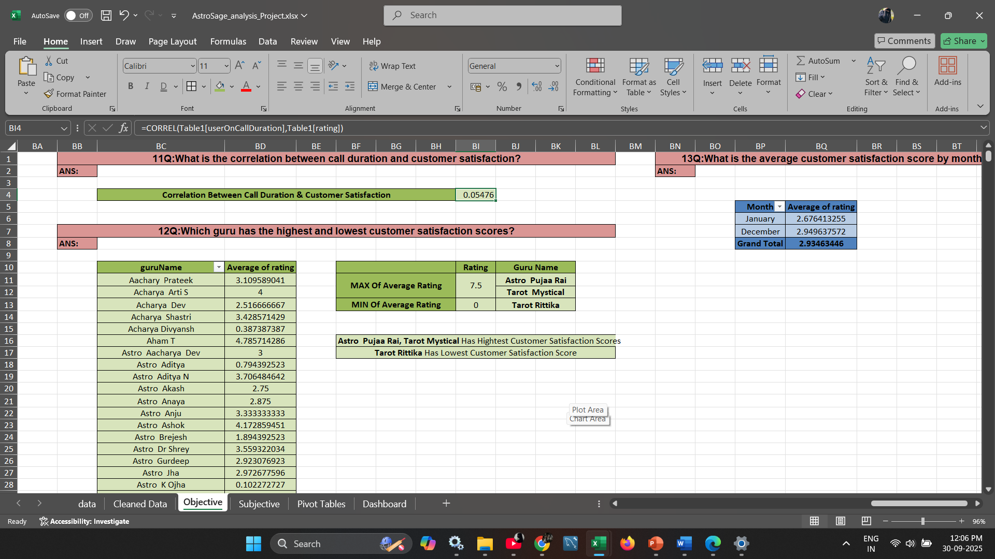

**Q12**: Which guru has the highest and lowest customer satisfaction scores?

**ANS:**  **To determine the highest and lowest customer satisfaction scores:**

* I created a **Pivot Table** with **guruName** in the Rows section.
* In the Values section, I added:
  + **Average of Ratings** to assess satisfaction level.
* I then sorted the Average Rating column in **descending order**.
* This allowed me to quickly identify:
  + The **top two astrologers** with the **highest average rating of 7.5**.
  + The astrologer with the **lowest rating of 0**, which was **Tarot Rittika**.

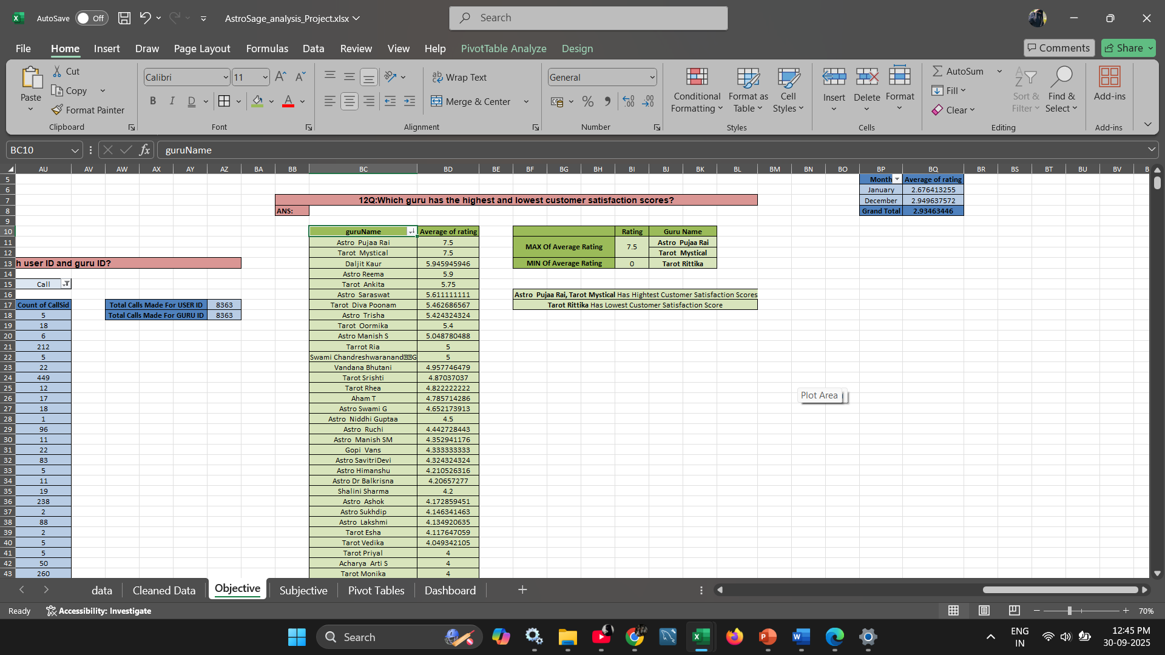

**Q13**: What is the average customer satisfaction score by month?

**ANS: To calculate the average customer satisfaction score by month:**

* I created a **Pivot Table**.
* Placed **Month** in the **Rows** section.
* Added the **Average of Ratings** to the **Values** section.
* This provided a clear view of customer satisfaction that varied across different months

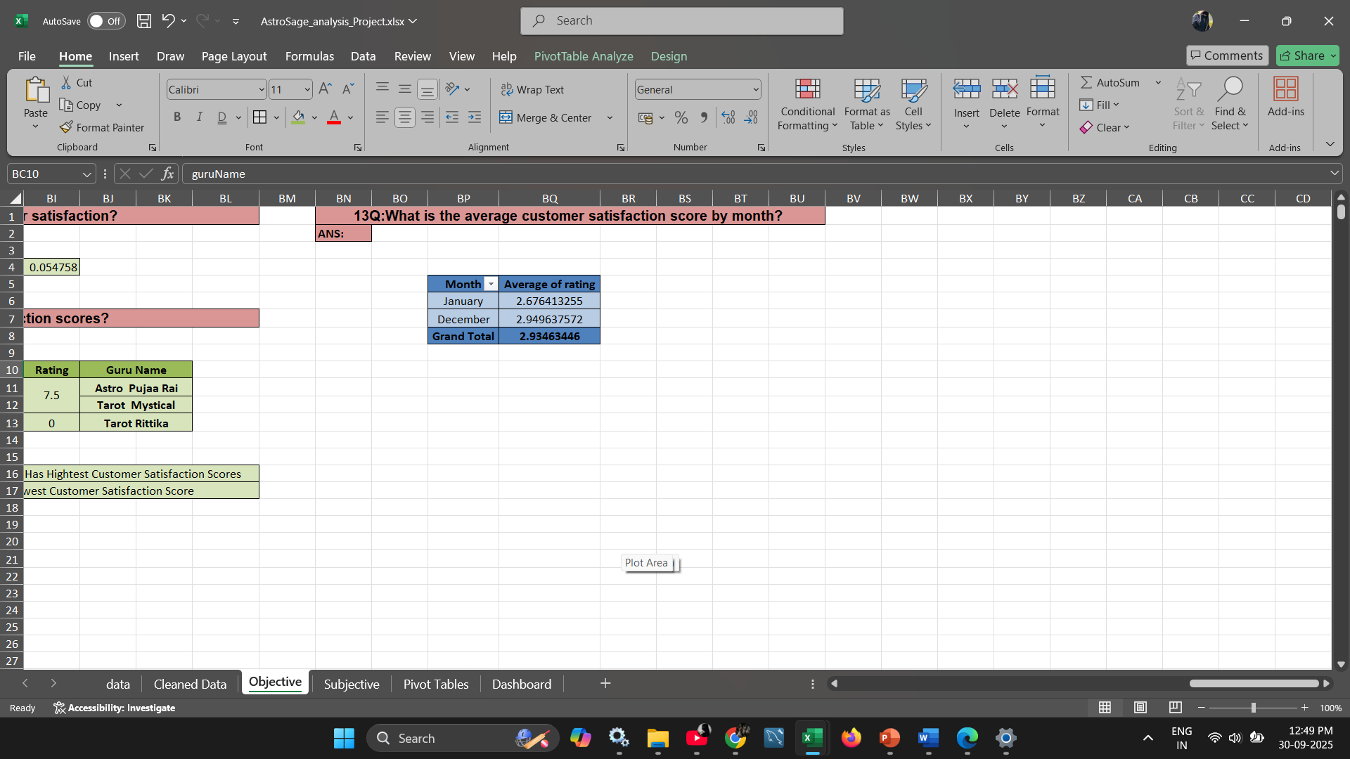

**Q14:** How many categorical columns are there in the data? [Search about categorical and continuous data, and try to answer this question]

**ANS:** After performing data cleaning and restructuring, the dataset now contains **11 categorical columns** based on the revised and refined data structure.

**chatStatus, guruName, consultationType, website, callChannel, callIvrType, callStatus, astrologerCallStatus, region, userCallStatus, ConsultationStatus**

**--------------------------END OF OBJECTIVE QUESTIONS-------------------------------------**

**ANSWERS OF SUBJECTIVE QUESTIONS**

**Q1**: Should the investment be used to hire more agents, improve training programs, or upgrade call center technology?

**ANS:**

**Approach:**

### To evaluate the best area of investment for AstroSage’s call center, I analyzed the dataset using **PivotTables, averages, and call/rating distributions**. The analysis focused on three possible investment options — hiring more agents, improving training, and upgrading technology — based on workload, performance, and efficiency indicators.

### **Reference:**

* **Excel Tools Used:** PivotTable, Pie Chart, Bar Chart, Column Chart
* **Functions:** COUNT, AVERAGE
* **Metrics Analyzed:**
  + Average calls per agent per day
  + Average call duration
  + Call success/failure rates
  + Average rating by Guru

### **Insights & Recommendations:**

#### **1. Hiring More Agents**

**Findings:**

* Avg. calls per agent per day = **2** (8,508 calls ÷ 148 agents ÷ 34 days).



* Top 10 Gurus handled >10,000 calls combined, while the bottom 10 handled only 24.

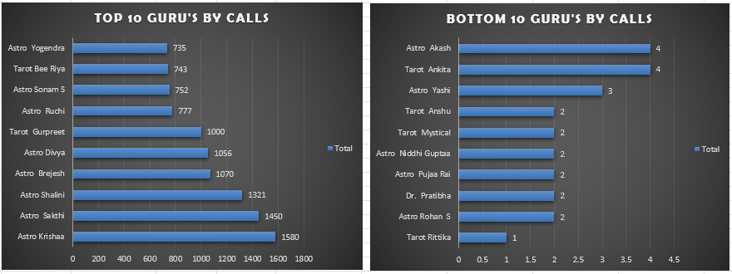

* Indicates workload imbalance and underutilization.

**Insights:**  
The current workforce is **not overburdened**; inefficiency is due to **uneven call distribution**, not a manpower shortage.

**Recommendations:**

* Avoid immediate hiring.
* Implement **smart call routing** to balance workload.
* Hire only if **future call demand** increases or top performers remain overloaded.

#### **2. Improving Training Programs**

**Findings:**

* Avg. ratings range from **7.5 (top Gurus)** to **below 1.0 (bottom Gurus)**.

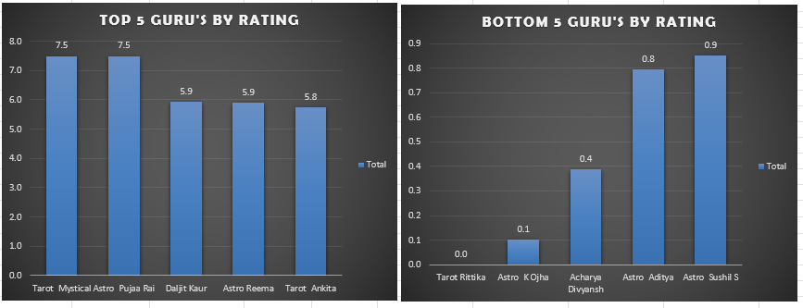

* Some Gurus with **long call durations** (e.g., Astro Aishwarya – 417 sec, Astro Anju – 387 sec) still get low ratings (3.3–3.6).

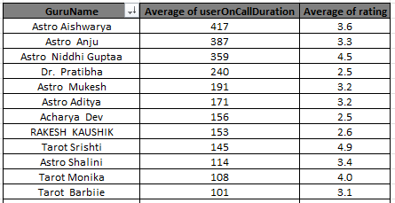

* Others like **Tarot Srishti (145 sec, 4.9)** and **Astro Lakshmi (69 sec, 4.1)** handle short calls with high ratings.

**Insights:**  
Differences in **skill, communication, and efficiency** drive customer satisfaction.  
High performers set a **benchmark** for effective communication and time management.

**Recommendations:**

* Develop **structured training modules** based on top-performer practices.
* Conduct **regular coaching** for low performers.
* Use **performance dashboards** (Rating vs Avg. Call Duration) to monitor improvement.

#### **3. Upgrading Call Center Technology**

**Findings:**

* 34% of calls failed or went unanswered (13.9% failed + 20.3% no answer).

* **Call Outcomes:** 40.5% completed, 59.5% failed/busy/no-answer/incomplete.
* **Chat Outcomes:** Only 28% completed, 71% failed/incomplete.
* Indicates serious **technology inefficiency**.

**Insights:**  
Outdated technology is **directly causing call drops, customer frustration, and lost productivity**.

**Recommendations:**

* Upgrade to a **CRM system** with smart routing and monitoring.
* Improve **IVR & call back systems** to reduce failed/no-answer calls.
* Enable **real-time dashboards** for supervisors to track performance.

### **Final Priority Order:**

1. **Upgrade Technology (High Priority)** – Resolves call drop issues and improves efficiency.
2. **Improve Training (Medium Priority)** – Enhances quality and reduces repeat calls.
3. **Hire More Agents (Low Priority)** – Only when demand significantly rises.

**Analytical Tools Used:**

* PivotTable/Pie chart (Calls by Status, Avg. Rating by Guru).
* Bar Chart (Guru Rating comparison).
* COUNT & AVERAGE functions to summarize efficiency.

**Q2**: What are the potential risks of each investment option (hiring, training, technology upgrades), and how can they be mitigated?Name the chart/spreadsheet function you will use for solving the problem.

**ANS:** - On the basis of above Analysis:

**1. Hiring More Agents**

**Potential Risks:**

* **Overstaffing:** If call volumes remain stable, new hires may be underutilized, leading to increased cost without a proportional return.
* **Increased Operational Costs:** Salaries, onboarding, and HR overhead add to fixed costs.
* **Dilution of Quality:** Rapid hiring may compromise quality if training cannot keep up.

**Mitigation Strategies:**

* Conduct a **workload capacity analysis** before hiring.
* Implement **flexible or contractual hiring** to manage demand surges.
* Continuously monitor **calls per agent** to balance workforce distribution.

**Chart/Function:**

* **Function:** =COUNTA( ), =UNIQUE( ), and call-per-agent ratio calculation.
* **Chart:** **Bar chart** comparing current agent count vs. call volume trend.

**2. Improving Training Programs**

**Potential Risks:**

* **Ineffective Training Modules:** Training may not align with real challenges faced by agents.
* **Downtime:** Time spent in training may reduce call-handling capacity temporarily.
* **Low Adoption Rate:** Agents may resist new methods or tools introduced.

**Mitigation Strategies:**

* Use **post-training feedback** forms and measure improvement in customer ratings.
* Schedule training in **low-call-volume hours** to minimize disruption.
* Create a **gamified learning experience** to boost engagement and adoption.

**Chart/Function:**

* **Function:** =CORREL() to measure pre- and post-training impact on rating.
* **Chart:** **Line chart** showing customer satisfaction before and after training interventions.

**3. Upgrading Call Center Technology**

**Potential Risks:**

* **High Upfront Cost:** Infrastructure upgrades require capital-intensive investment.
* **Implementation Downtime:** Transitioning to new tools may temporarily disrupt service.
* **Training Gap:** Staff may struggle with unfamiliar systems if not trained properly.

**Mitigation Strategies:**

* Start with **pilot rollouts** and scale in phases.
* Ensure **vendor support and onboarding workshops** are part of the contract.
* Train agents **before** full deployment with simulations.

**Chart/Function:**

* Function: Use =COUNTIF() to measure failure rates pre- and post-implementation.
* **Chart:** **Stacked column chart** showing completed vs. failed consultations across channels.

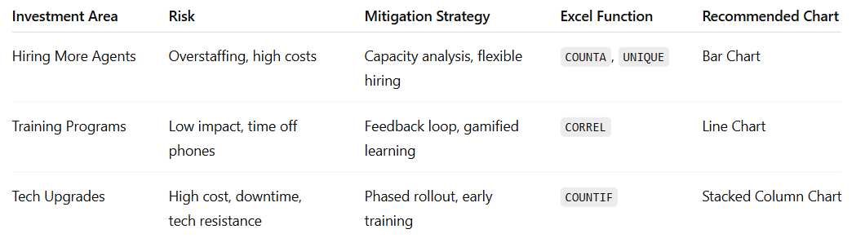

**Q3**: How does AstroSage's call center performance compare to AstroGuru's average call volume, customer satisfaction, and agent performance? Will you use any aggregation function or a visualization here to solve the problem?

**ANS:** Currently, no dataset is available for AstroGuru, which prevents direct comparison. However, if such data were made available, a comprehensive benchmarking analysis could be conducted across key performance metrics such as:

**Key Comparison Metrics:**

* **Average Call Volume**
  + Use AVERAGEIFS to calculate average calls handled per agent, per day or per shift.
  + Use COUNTIFS to segment total calls by company, consultation type, or agent.
* **Customer Satisfaction**
  + Utilize customer ratings, calculating average satisfaction scores using AVERAGEIFS by astrologer and consultation type.
  + Map rating trends over time to see consistency and reliability.
* **Agent Performance**
  + Analyze calls handled per astrologer using a bar chart.
  + Identify top performers by combining metrics like number of calls, customer ratings, and consultation completion rates.
* **Revenue Analysis**
  + Compare **Net Revenue per Call** using calculated fields in pivot tables (e.g., Revenue / No. of Completed Consultations).
  + Use stacked columns to visualize completed vs failed consultations for both companies.

**Q4**: How can the call center improve its handling of peak call periods to ensure high customer satisfaction? Mention the functionality you will use for giving the suggestions, will it be any aggregated function or a visualization?

**ANS: Approach and Analysis:** To identify patterns in customer satisfaction and call volume, **two pivot tables** were created:

1. **Hour-wise Average Customer Rating**
2. **Hour-wise Call Distribution**

**Key Insight:**

* At **8:00 AM**, there is a noticeable **spike in both call volume and completed consultations**, indicating a peak traffic period where performance strongly impacts overall satisfaction.

**Functionality Used:**

* **Aggregation Functions:**
  + AVERAGEIFS – to calculate average ratings by hour
  + COUNTIFS – to count calls by time slots, call status, and consultation type
* **Visualization Tools:**
  + **Pivot Tables & Pivot Charts** – to analyze call patterns and satisfaction
  + **Bar Charts** – to illustrate hourly trends and performance spikes

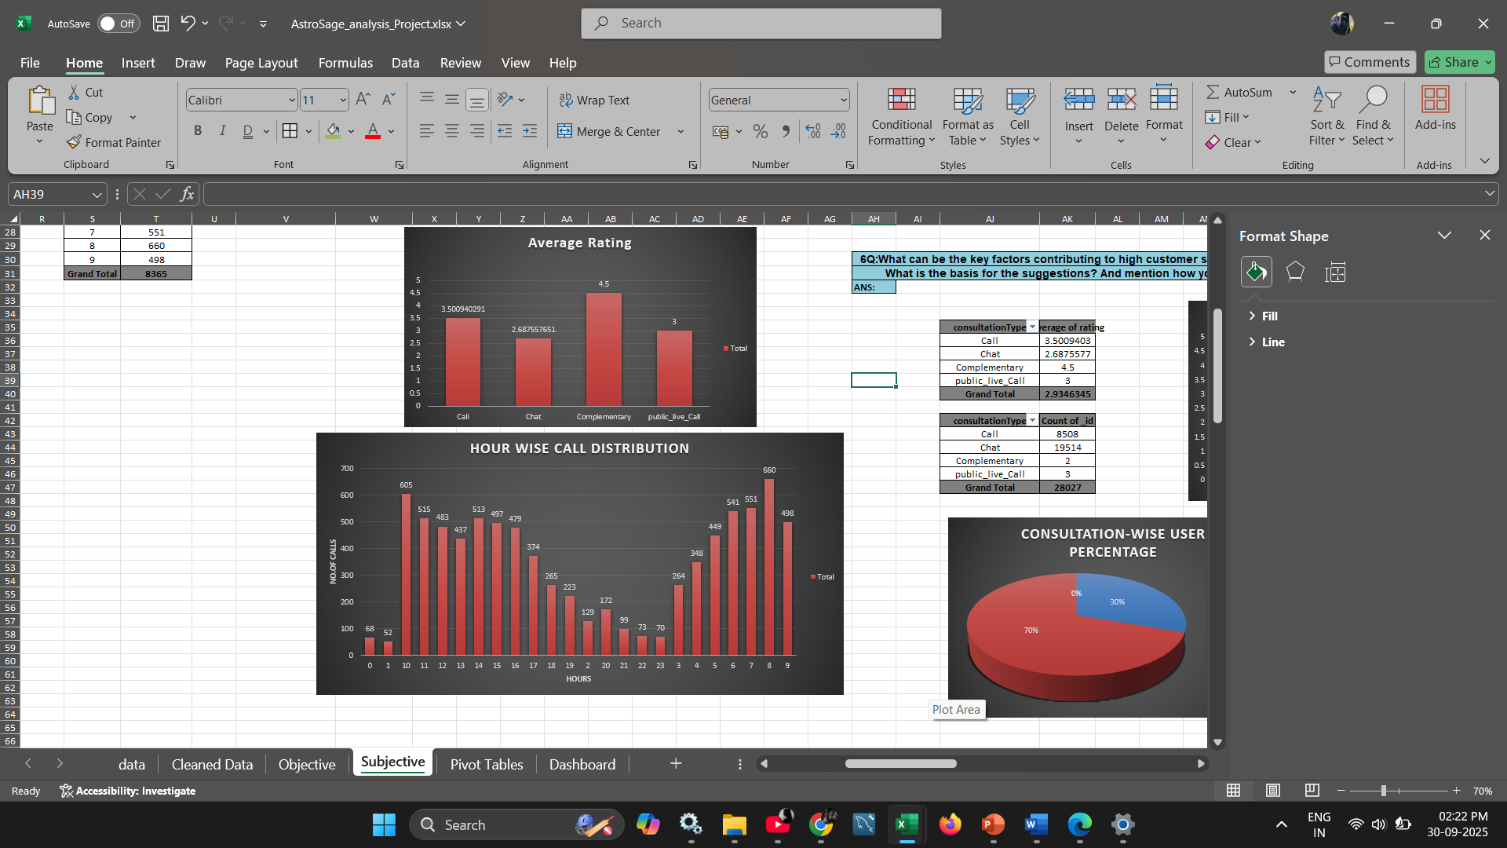

**Recommendations to Optimize Peak Hour Handling:**

**1. Smarter Scheduling**

* Use historical data to forecast high-demand periods like 8:00 AM.
* Schedule more agents during these hours to reduce queue times and prevent overload.
* Prepare staffing buffers during holidays, weekends, or astrological events.

**2. Better Queue Management**

* Implement dynamic queue systems with:
  + Estimated wait time notifications
  + Priority tagging for urgent consultations
* Monitor queues in real-time and adapt routing as needed.

**3. Use Technology Wisely**

* Deploy **AI chatbots** for routine queries and FAQs.
* Enhance **IVR systems** to efficiently route customers to appropriate agents.

**4. Proactive Communication**

* Notify users about expected delays during peak hours through SMS, app, or IVR announcements.
* Promote self-service channels (FAQs, knowledge base, WhatsApp bots) during peak periods.

**5. Smarter Call Routing**

* Use **skills-based routing** to connect customers with the most relevant astrologer or support agent.
* Improve First Call Resolution (FCR) by matching agent expertise with query type.

**6. Listen and Improve**

* Collect customer feedback immediately after peak hour interactions.
* Analyze comments to continuously fine-tune call handling, scripts, and agent training.

**Q5**: Based on historical data, what strategic initiatives should be prioritized to improve efficiency and customer satisfaction?

**ANS: Approach** Using the following visuals:

1. **Call Status Distribution**
2. **Chat Status Distribution**
3. **Average Ratings by Platform (App, Dashboard, Gurucool)**
4. **Hour wise Call Distribution**

We derived insights using **pivot tables** and **pie charts** to assess channel effectiveness and performance gaps across touchpoints.

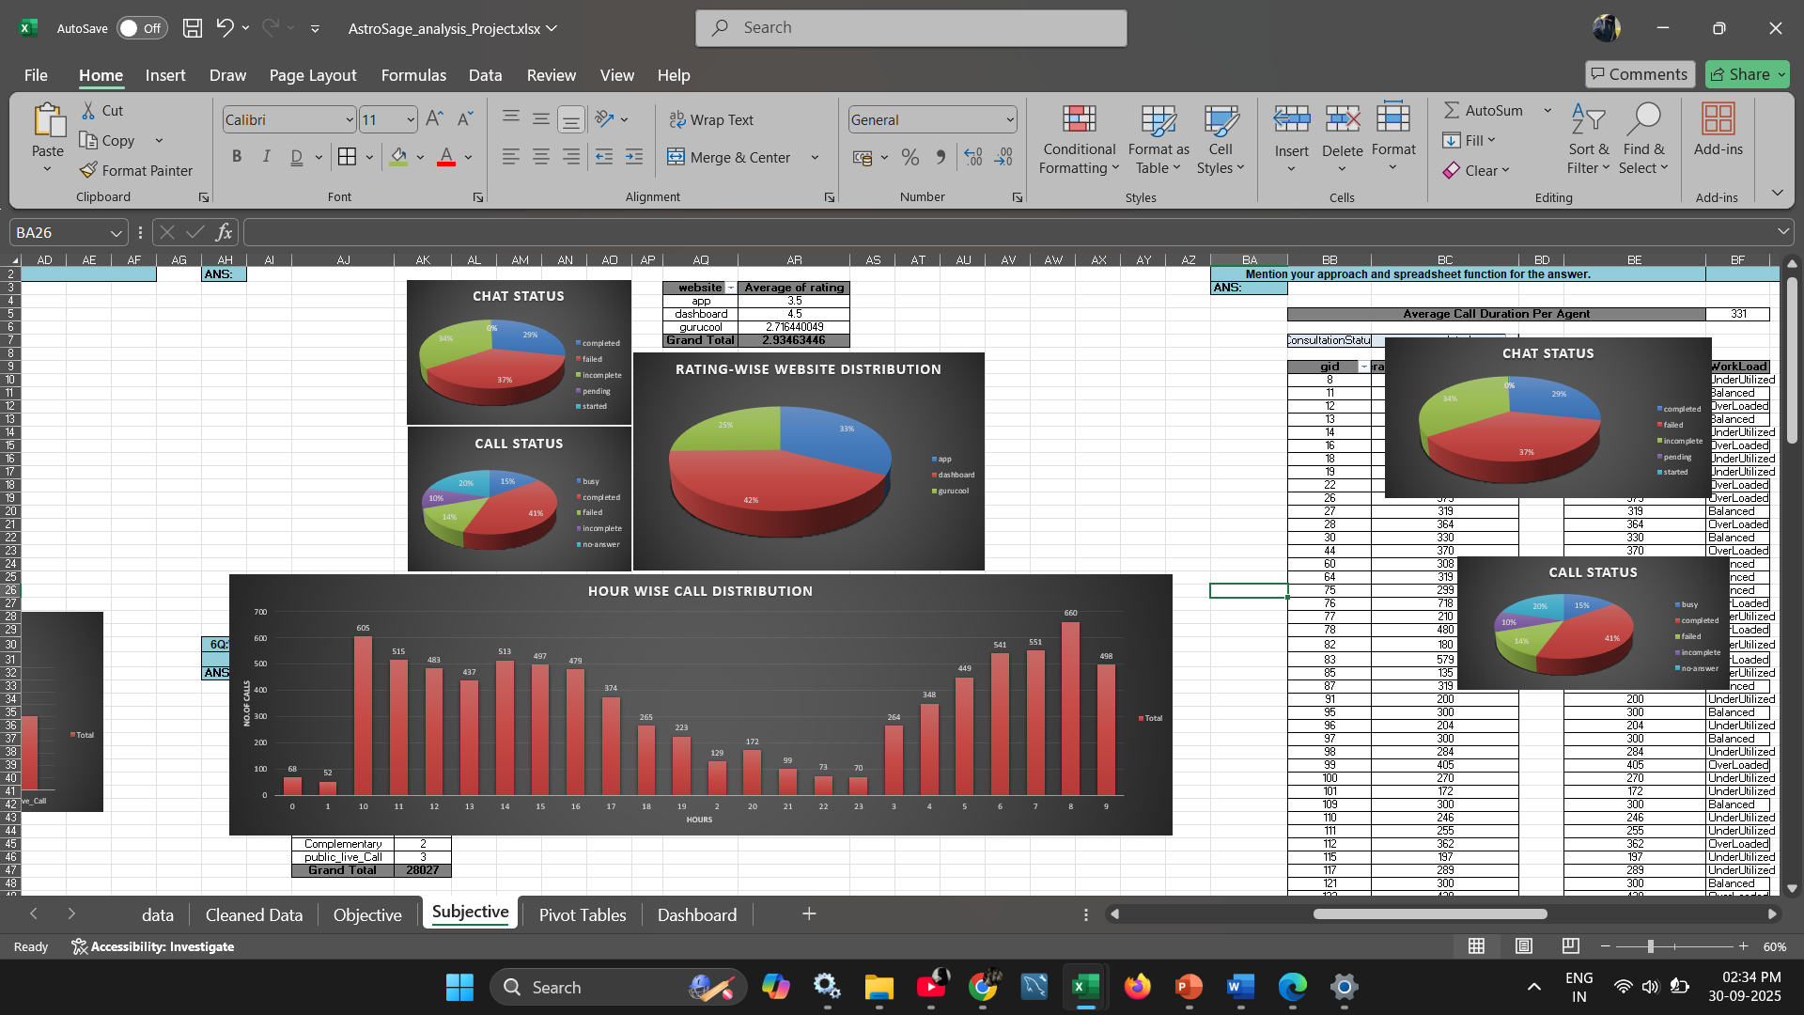

**Key Insights:**

* **High Failure Rates**:
  + **Chats**: 37% failed, 34% incomplete.
  + **Calls**: 14% failed, 10% incomplete.
* **Performance by Platform**:  
  + **Dashboard** has the highest average rating (42%), followed by **App** (33%), and **Gurucool** (25%).
* **Only 29% of chats and 41% of calls are successfully completed**, indicating major drop-offs.

**Recommendations:**

**1. Fix Chat Performance First (Top Priority)**

Chats show the highest failure rate and lowest completion.

**Action Plan:**

* Integrate **AI chatbots** to handle basic queries efficiently.
* Train chat agents in structured, empathetic communication.
* Add auto-escalation to calls for unresolved chat issues.

**2. Reduce Failed & Incomplete Calls**

**37% chats** + **14% of calls** end without resolution.

**Action Plan:**

* Audit call failures to identify root causes (tech, agent, connectivity).
* Implement a **callback system** for missed/incomplete calls.
* Enable **live agent dashboards** to manage peak loads dynamically.

**3. Upgrade Technology Infrastructure**

High failure/incomplete rates point to systemic performance gaps.

**Action Plan:**

* Upgrade both chat and call systems for stability.
* Use **real-time monitoring tools** to detect downtime or system lag.
* Ensure platform optimization across **App, Dashboard, and Gurucool**.

**4. Leverage High-Performing Platforms**

Dashboard users are most satisfied (avg. rating: 4.5).

**Action Plan:**

* Enhance **App** and **Gurucool** UX/UI to match dashboard experience.
* Roll out best practices from Dashboard UI across other platforms.

**Q6**: What can be the key factors contributing to high customer satisfaction scores, and how can these be leveraged to improve overall performance? What is the basis for the suggestions? And mention how you decided if the satisfaction score affects the ratings.

**ANS: Key Factors Contributing to High Customer Satisfaction Scores**

1. **Fast Handling Time (2.56 minutes):** Quick resolution often improves customer perception—long waits can lower satisfaction.
2. **Low Refund Percentage (0.0178%):** Indicates accurate, reliable service, which builds trust.
3. **Zero Wait Time (0%):** Immediate attention reduces frustration, positively impacting satisfaction.
4. **Agent Skill & Knowledge:** Experienced or well-trained agents can resolve issues efficiently and empathetically.
5. **Quality on Non-Peak Days:** Higher ratings on non-peak days show that time and attention given by agents directly influence satisfaction.

**How to Leverage These Factors:**

1. **Promote Best Practices from High-Performing Agents:** Analyze top-rated agents’ behaviors and replicate their techniques across the team.
2. **Forecast and Staff for Peak Periods:** Apply historical peak-hour trends to schedule additional agents or enable virtual holds, ensuring consistent service quality.
3. **Strengthen Training on Empathy and Communication:** Satisfaction dips on busy days suggest agents need strategies to stay personable under pressure.

**Basis for These Suggestions**

1. Using Pivot Tables and Line Charts, we compared daily call volume with average satisfaction scores.
2. Observation: Satisfaction ratings dropped on peak days, indicating call quality is impacted by high workloads.

### 

**Decision on Satisfaction Score Affecting Ratings**

1. Direct Observation: Days with higher call volume showed lower ratings and shorter call duration.
2. Trend Validation: Visualization (line graphs) of call volume vs. ratings revealed a negative relationship—as volume increases, ratings decline.

### **Q7**:How should the call center balance the workload among agents to ensure optimal performance and avoid burnout? Mention your approach and spreadsheet function for the answer.

**ANS: Observation Summary:**

* **Average Call Duration per Agent:** 3301 seconds (calculated across all completed consultations).
* Each agent’s **Average Consultation Duration** is compared to this benchmark.
* The workload is then categorized as:
  + **Overloaded:** > 330.5 sec
  + **Balanced:** within 10% range (297.45 sec to 330.5 sec)
  + **Underutilized:** < 297.45 sec

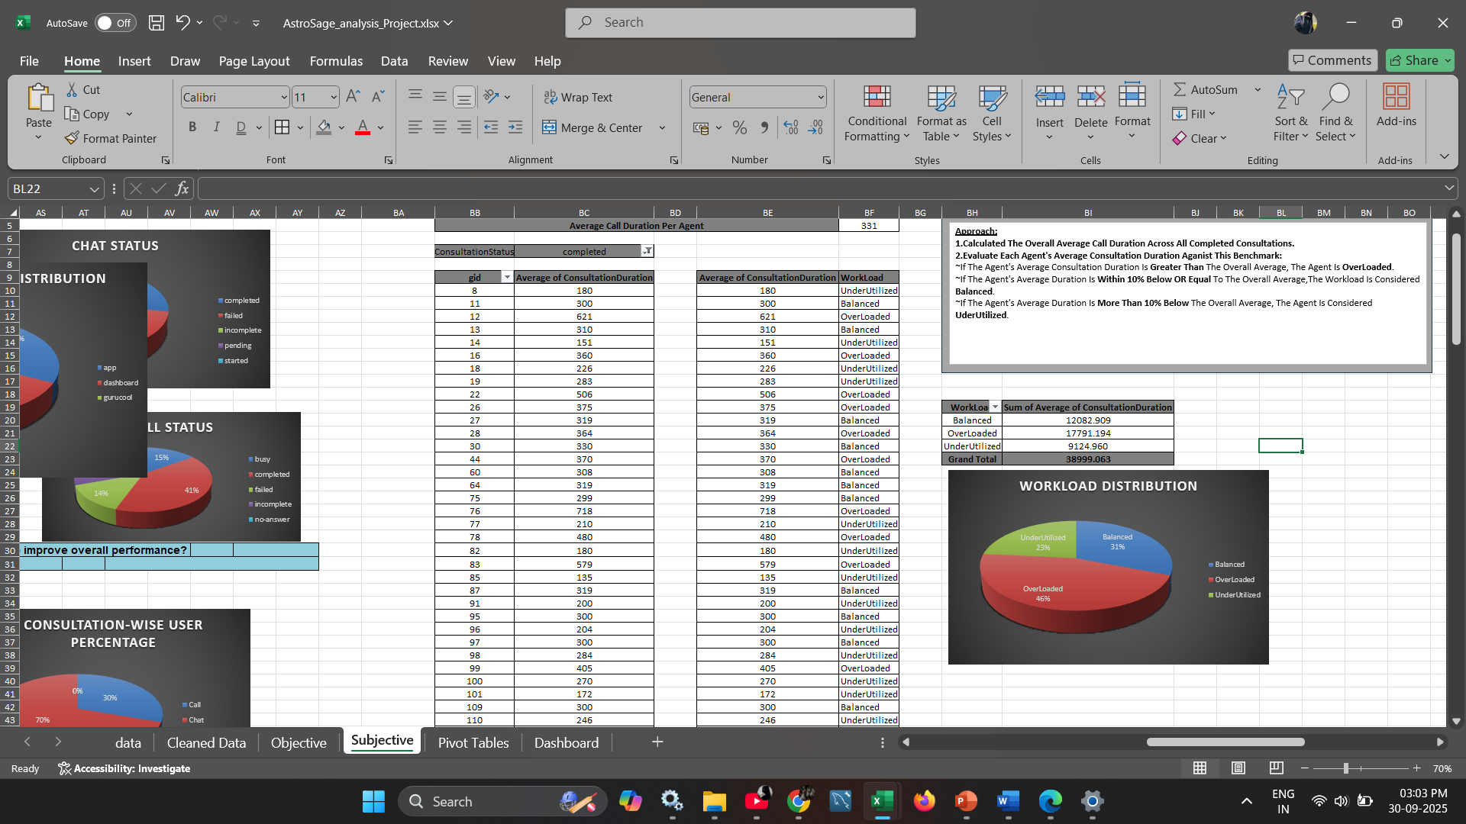

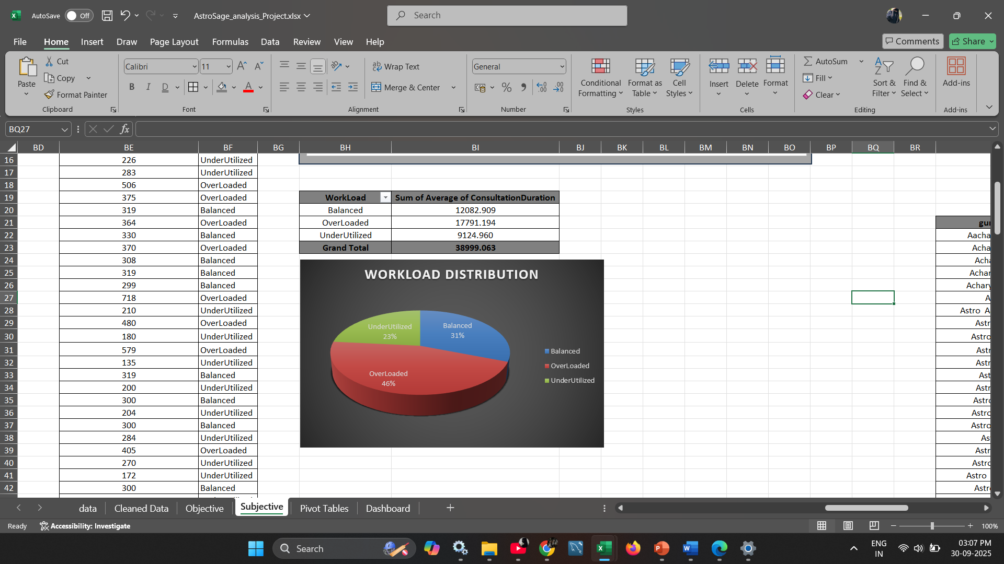

**Approach Used to Evaluate Workload:**

1. **Step 1: Calculate Overall Average Call Duration**
   * **Function used:** =AVERAGEIF([ConsultationStatus], "completed", [Call Duration])
   * Result: **331 seconds**
2. **Step 2: Determine Workload Category**
   * Each agent’s average consultation duration is compared to the benchmark using nested **IF** logic:   
     **=IF(AverageDuration > 331 "Overloaded", IF(AverageDuration < 297.45, "Underutilized", "Balanced"))**
   * This logic categorizes workload for each agent.
3. **Step 3: Summarize & Visualize Workload**
   * Using **Pivot Table** to calculate:
     + Count and sum of durations in each workload category.
   * **Pie Chart** to visualize:
     + **Overloaded** agents: **46%**
     + **Balanced** agents: **31%**
     + **Underutilized** agents: **23%**

**Insights & Recommendations:**

1. **Immediate Rebalancing Needed**
   * With **46% of agents overloaded**, there is a clear risk of **burnout, reduced efficiency, and quality degradation**.
   * **Recommendation:** Redistribute tasks from overloaded agents to underutilized ones to normalize workloads.
2. **Agent Performance Monitoring**
   * Continuously monitor average consultation durations weekly to flag imbalances early.
   * **Automate workload categorization** using Excel formulas for real-time tracking.
3. **Operational Adjustments**
   * **Train underutilized agents** to handle more complex or time-intensive cases.
   * **Revisit shift allocation** to align agent capacity with peak consultation hours.

**Conclusion:**

A data-driven workload balancing approach ensures:

* **Agent well-being**,
* **Higher customer satisfaction**, and
* **Sustainable team performance**.

**Q8**: What new technologies or tools could be implemented to enhance call center operations and customer service?

**ANS:** To make the call center work better and help customers faster, we can use some new tools and technologies like:

* **Automatic Call Distribution:**  This sends calls to the right agent quickly.
* **Interactive Voice Response:** This helps customers get simple answers by pressing buttons, without waiting for an agent.
* **Chatbots:** Chatbots can answer common questions right away and save time.
* **Call Back Option:** Customers can choose to get a call back instead of waiting on hold.
* **CRM Tools:** These tools help agents see customer details fast so they can give better help.
* **Live Monitoring Tools:** These help managers see real-time call data and solve problems quickly.
* **Speech Analytics:** This tool can check call quality and customer mood by listening to calls automatically.
* **Omnichannel Support:** This connects calls, chats, emails, and social media in one place so customers can switch easily.

**Q9**: What metrics should be included in the final dashboard to comprehensively view call center performance and guide investment decisions?

**ANS:** The final dashboard should include the following important metrics to fully understand the call center’s performance and help in making investment decisions:

**1. Key Performance Indicators (KPIs):**

* **Total Sessions:** (e.g., 28027) – Indicates overall activity level.
* **Active Agents:** (e.g., 128) – Helps monitor resource availability.
* **Repeat Callers %:** (e.g., 56.6%) – Reflects customer retention or repeated issues.
* **Operational Cost:** (e.g., 77799.44) – Critical for cost-efficiency and ROI planning.

**2. Revenue Insights:**

* **Revenue by Consultation Type:** Shows earning sources (Call, Chat, Complimentary) – useful to allocate resources or boost specific services.

**3. Quality of Service Metrics:**

* **Guru Rating Distribution:** Measures customer satisfaction across various agents.
* **Top 10 Gurus with Highest Ratings:** Useful for performance benchmarking and training allocation.

**4. Call Handling Efficiency:**

* **Call Status Distribution:** (completed, failed, pending, etc.) – Important for SLA adherence and agent effectiveness.
* **Call Distribution over Hours:** Highlights peak traffic times for optimal staffing.
* **Number of Consultations per Day:** Tracks daily demand trends to plan capacity and forecast volume.

**5. User Behaviour:**

* **Website Distribution (app vs. web):** Helps decide where to invest in UX/UI enhancements.
* **Users by Consultation Type:** Guides user preferences and service utilization.

**6. Filter Capabilities for Deep Dive:**

Filters like region, year, consultation type, and rating allow dynamic slicing of data – critical for tailored insights.

**Q10**: How would you allocate a 1 crore rupee investment to optimize operational efficiency, enhance customer satisfaction, and boost profitability, and what analysis-based recommendations would you offer to support this?

**ANS:** To enhance **operational efficiency, customer satisfaction**, and **overall profitability** based on the consultation performance data analyzed.

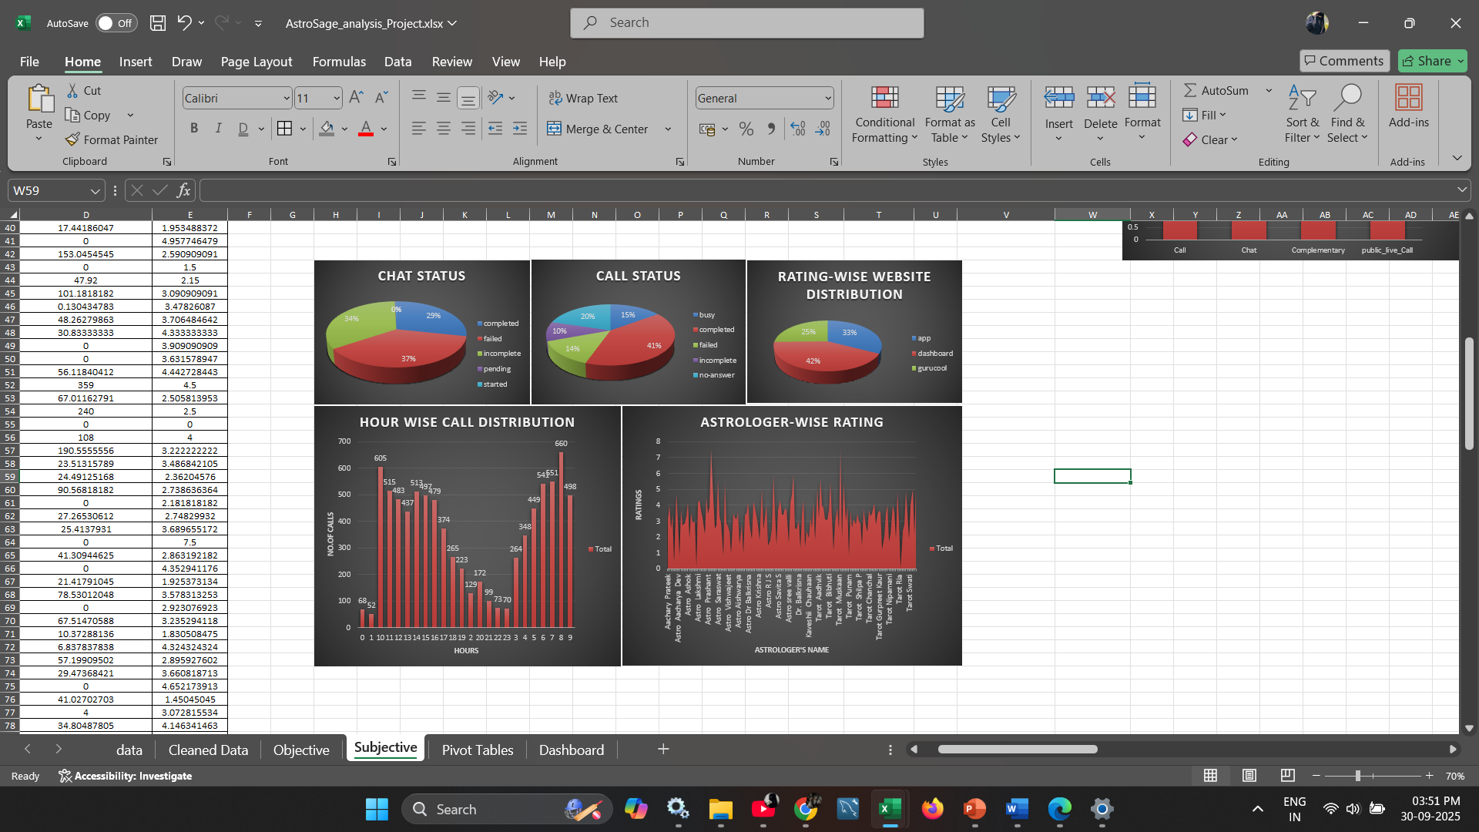

**Investment Plan:**

* **40% – Hire More Agents and Improve Training**
  + **Reason:**
    - 83.60% of the total workload is managed by overloaded agents (as per workload analysis).
    - New agents will help balance the load and reduce agent burnout.
    - Training will help agents handle calls efficiently and improve customer service.
* **25% – Upgrade Call Center Technology**
  + **Reason:**
    - Using AI chatbots and automation tools can handle common and repeat queries.
    - Smart call routing can save waiting time and make the process faster.
    - This will improve both **operational efficiency and customer satisfaction.**
* **20% – Enhance Customer Experience**
  + **Reason:**
    - Satisfaction scores are not heavily affected by call duration (correlation: -0.06).
    - Customers prefer **quick and quality resolutions.**
    - Invest in faster feedback collection, customer support tools, and self-service portals to boost satisfaction.
* **10% – Performance Monitoring & Real-Time Dashboards**
  + **Reason:**
    - Regular dashboards help track agent workload, ratings, consultation status, and customer feedback.
    - Helps managers take **quick, data-based decisions.**
* **5% – Rewards & Motivation Program for Agents**
  + **Reason:**
    - Motivated agents perform better and stay longer.
    - Incentives for high-rated agents can improve overall service quality and reduce attrition.

## 

## **Analysis-Based Support:**

* **Workload Distribution:**
  + Overloaded agents handle **46%** of total call durations.
  + Call distribution is not balanced.
* **Customer Type:**
  + **56.6% repeat callers** – focus on improving their experience for long-term retention.
* **Revenue Source:**
  + **79% of revenue comes from call-based consultations** – priority should be on optimizing call handling.
* **Customer Satisfaction:**
  + Satisfaction score has a **low impact from call duration** (correlation: 0.0547), meaning faster resolutions are more important than longer consultations.

**--------------------------END OF SUBJECTIVE QUESTIONS-----------------------------------**